SVPM’S
SHIVAI VIDYALAY ENGLISH MEDIUM AND JUNIOR COLLEGE
STD:- VIII WORKSHEET SUB:- MATH

Q.1) SOLVE
1) X³-2X²+4 ÷ X-2 2)4X³-2X²-3 ÷ 2X²-1
3)12X³-11X²+9X +18 ÷ 4X+3
4) 3X²+4X+11 ÷ X²-3X+2
5) 8X⁴-4X²+2 ÷ 2X²
Q.2) Answer the following question
a) If the radius of a circle is 5 cm and chord length is 9 cm.find the distance of a chord from the centre.
b) The distance from centre to chord is 13cm.and chord length is 28 cm.find the diameter length.
c) A chord of a circle is 30 cm long. Its distance from centre is 8 cm. find the radius of a circle.
D)In the given figure, O is the centre of the circle whose diameter is MN. Measures of some central angles are given in the figure.
i. m∠AOB and m∠COD
ii. Show that arc AB ≅ arc CD
iii. Show that chord AB ≅ chord CD
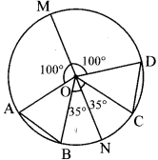

SVPM’S
SHIVAI VIDYALAY ENGLISH MEDIUM AND JUNIOR COLLEGE
STD:- VIII WORKSHEET SUB:- MATH

Q.1) Observe the following graph and answer the questions.
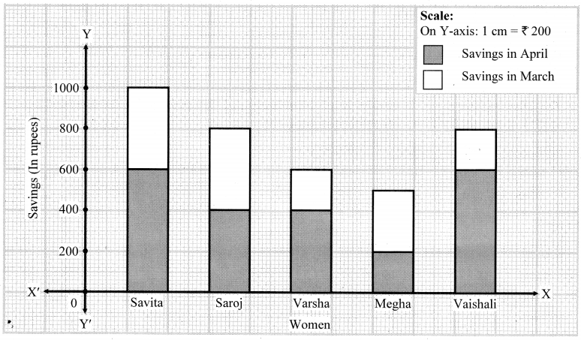
i. State the type of the graph.
ii. How much is the savings of Vaishali in the month of April?
iii. How much is the total of savings of Saroj in the months March and April?
iv. How much more is the total savings of Savita than the total savings of Megha?
v. Whose savings in the month of April is the least?

Q.2) The number of boys and girls, in std 5 to std 8 in a Z.P. School is given in the table. Draw a subdivided bar graph to show the data. (Scale : On Y axis, 1cm = 10 students)
Standard | 5th | 6th | 7th | 8th
Boys | 34 | 26 | 21 | 25
Girls | 17 | 14 | 14 | 20

Q.3) In the following table, data of the transport means used by students in 8th standard for commutation between home and school is given. Draw a subdivided bar diagram to show the data.
(Scale: On Y axis: 1 cm = 500 students)
Means of commutation\Town | Paithan | Yeola | Shahapur
Cycle | 3250 | 1500 | 1250
Bus and auto | 750 | 500 | 500
On foot | 1000 | 1000 | 500

Age (years) | Frequency
10 | 0
11 | 8
12 | 3
13 | 2
14 | 7
Q.4) Find the mean of the set of ages in the table below

Q.6) Find the volume of cuboid of dimension 22 × 7.2 × 6.3 in m.
Q.7) If the radius of the base of the cylinder is 14 cm and its height 35 cm. Find its total surface area.
Q.8) The dimeter of a roller is 84cm and its length is 120 cm.it takes 500 complete revolutions to move once over to level a playground. Find the area of the playground in m².
Q.9) for a solid figure, the number of faces are 6 and number of edges are 10, then find the number of vertices that solid figure has. (use Euler’s Formula)
Q.10) The radius of the base of a cylindrical column of a building is 25 cm and its height is 3.5 m. if costs ₹ 15.50 per sq m to paint this column. What will it cost to paint 10 such columns?.

