SHIVAI VIDYALAYA ENGLISH MEDIUM
(PRIMARY SEC.)
 | SUB : English
STD. II | II SEMESTER EXAMINATION ( WORKSHEET)

Q.1. A) Fill in the blanks
(Green, small, shoes, up, over)
1. The child can go ________________ in the air and ________________ the wall.
2. The child can see the ________________________ garden.
3. A traveler reached a _________________________ village.
4. People do not want to __________________________
5. A Shoemaker mends _________________________.
B) Write True or False .
1. Siya and Adil were eleves. _____________________________
2. The villagers were rich. _____________________________
3. The eleves danced as they worked. _____________________________
4. The traveler was a clever man. _____________________________
5. Siya made clothes for the eleves. _____________________________
Q.2) Write the meaning of the following .
1. Perfect - __________________________________________
2. Pleasantest - _______________________________________
3. Delighted - _________________________________________
4. Invisible - __________________________________________
5. Cattle - ___________________________________________

Q.3) Write the answer of the following questions.
1. What are the things that the child can see when the swing goes up?
Ans- _________________________________________________________________________________
______________________________________________________________________________________
2. Why did the villagers not want to share?
Ans- _________________________________________________________________________________
______________________________________________________________________________________
3. What was the stone wrapped in?
Ans- _________________________________________________________________________________
______________________________________________________________________________________
4. Who stitched the leather into shoes at night?
Ans- _________________________________________________________________________________
_______________________________________________________________________________________
5. How did Siya and Adil thank the eleves?
Ans- _________________________________________________________________________________
_______________________________________________________________________________________
B) Write the yesterday words.
Pull - ________________________ 4. Wait - _________________________
2. Push - ________________________ 5.Cook- __________________________
3. Want- ________________________ 6.Ask - ___________________________

B) Match the Homes of animals.
1. Horse __________________________ a. hole
2. Pig __________________________ b. water
3. Cow __________________________ c. stable
4. Mouse ___________________________ d. sty
5. Fish ____________________________ e. shed
C) Write This or That.
1. 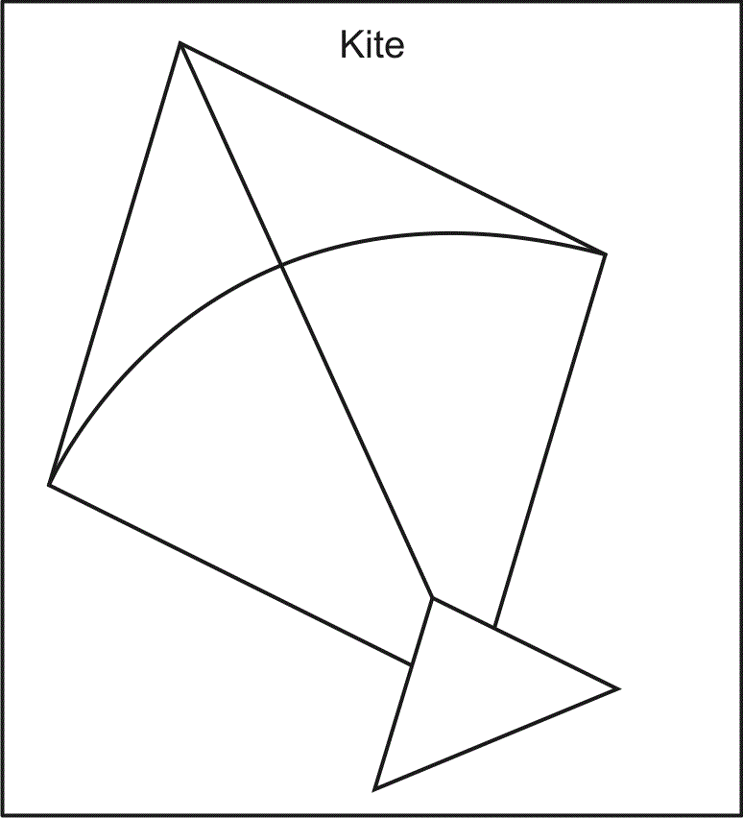 _______________________ is a kite.
2. _______________________ is a apple.
3. 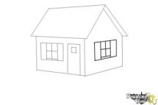 ____________________ is a house.
4. ________________________ is a leaf. 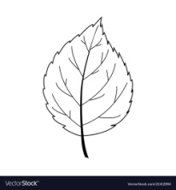
D) Fill in the blanks.
(Friends, clever, wise, first, lake second)
1. The three fishes lived in a ___________________
2. The first fish was _________________________

