S V P M ‘ S
Shivai Vidyalaya English Medium school & Jr.Collage
Olive Oodles (Pre-Primary )
Shivai Nagar ,Thane
Name :- Std :- SR.KG. Date:-
Subject :- G.K. Worksheet No :-5 Teacher’s Sign:-

Q1. Identify the pictures of machine & circle.
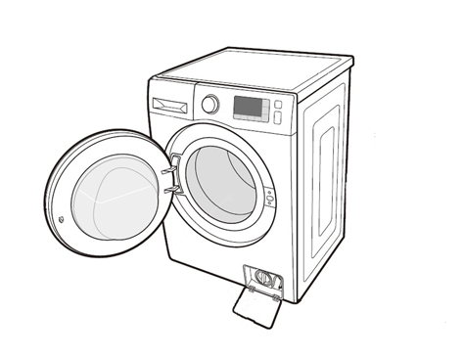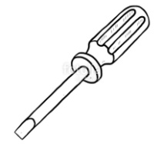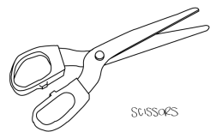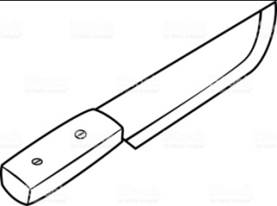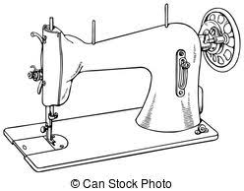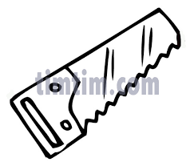

Q2. Draw the means of transport
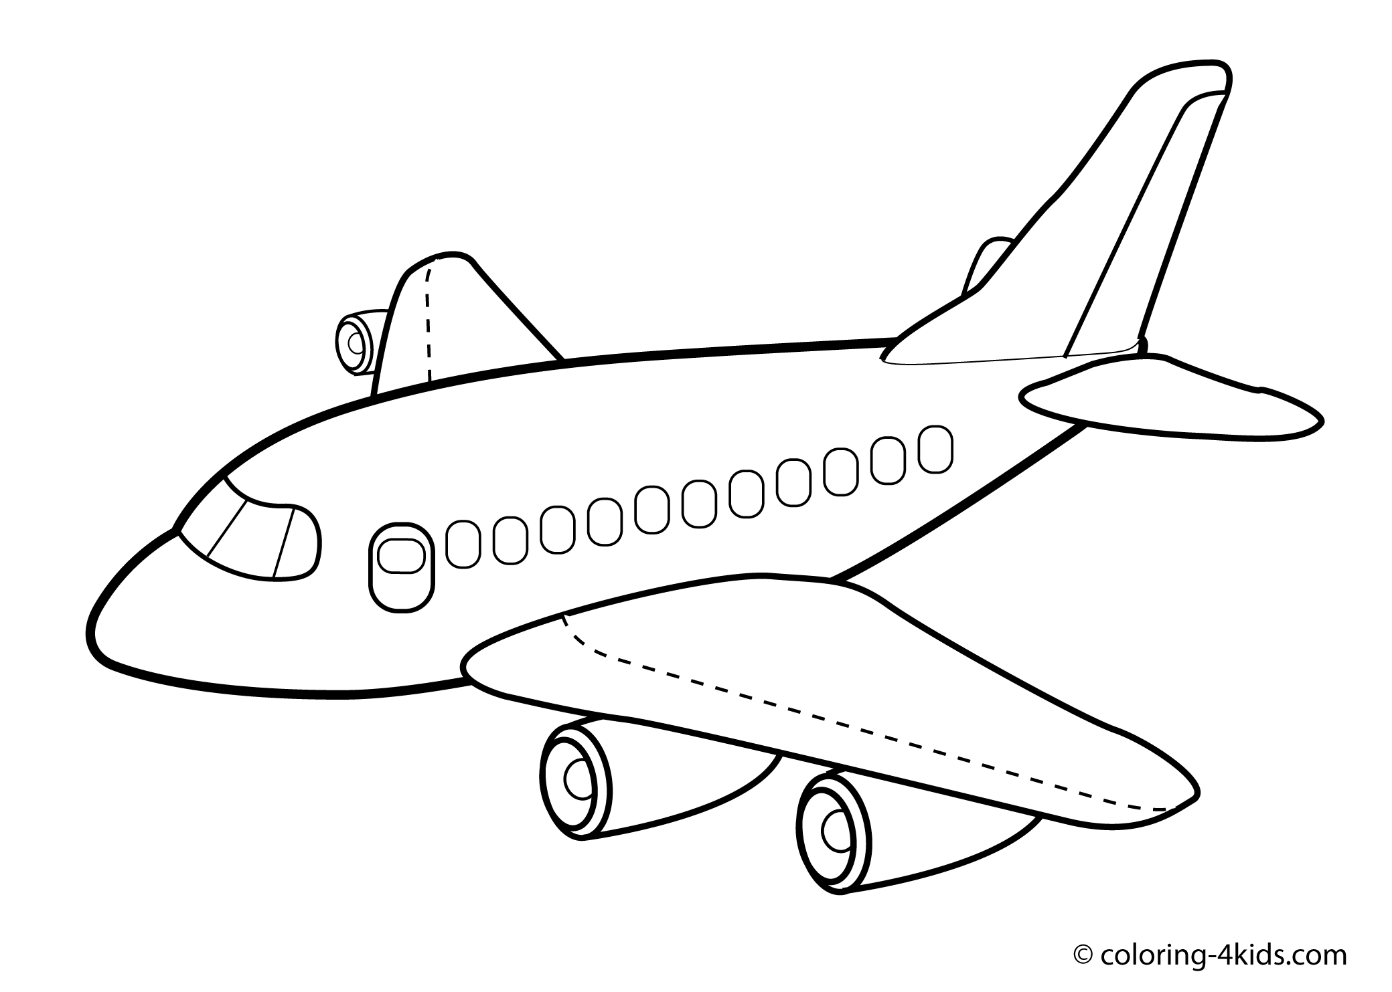

Q 3.Colour the vehicle that carry few people

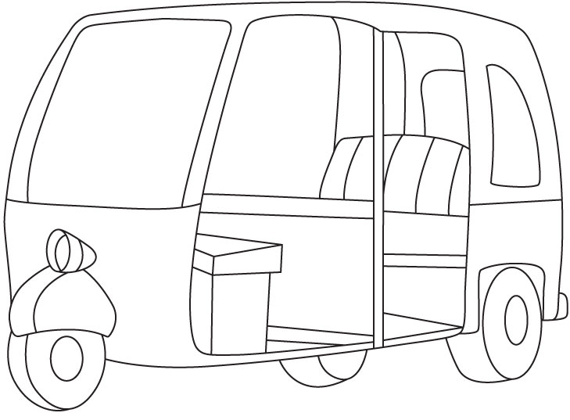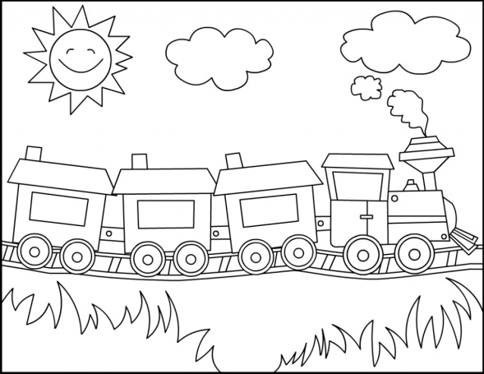
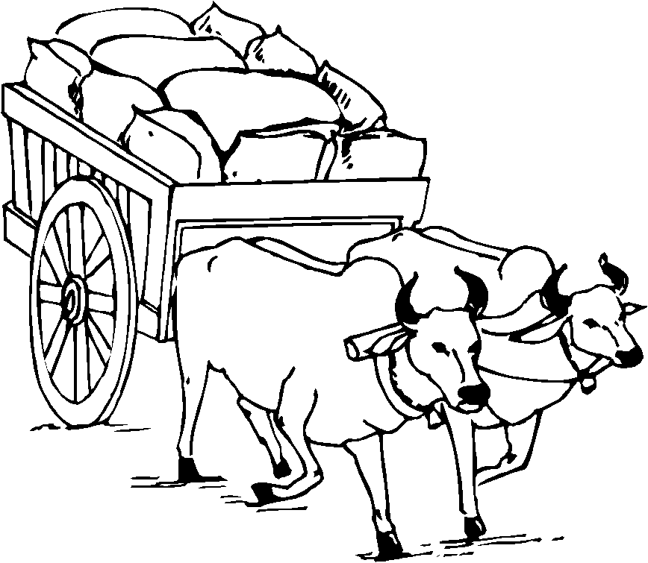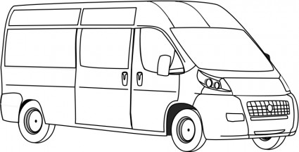

Q.4.Draw the things that you see on the road.

S V P M ‘ S
Shivai Vidyalaya English Medium school & Jr.Collage
Olive Oodles (Pre-Primary )
Shivai Nagar ,Thane
Name :- Std :- SR.KG. Date:-
Subject :- maths Worksheet No :-5 Teacher’s Sign:-

Q.1 Write Ordinal No.
Name | numbers
first
fifth
Ninth

Q.2[a] Write the nos. in ascending order
Given nos. | answer
5 10 8 2
7 9 4 0
8 1 3 5
[b]Write the nos. in descending order
Given nos. | answer
5 10 8 2
7 9 4 0
8 1 3 5

Q.3[a] Circle the big no.
5 10
0 9

[b] Circle the small no.
- 9
6 10
Q.4.Put < > = sign
10 7

6 9

4 4

Q.5. Subtraction
4 - 3 =

9 - 5 =

7 - 2 =

S V P M ‘ S
Shivai Vidyalaya English Medium school & Jr.Collage
Olive Oodles (Pre-Primary )
Shivai Nagar ,Thane
Name :- Std :- SR.KG. Date:-
Subject :- English Worksheet No :-5 Teacher’s Sign:-

Q 1. Match the rhyming picture
bun 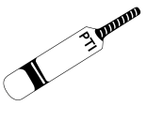
Pup
Mat
Q2. Write These / Those
- -------------------------are pins.

- ----------------- are cups

- --------------- are kites.

- ----------------- are balls. 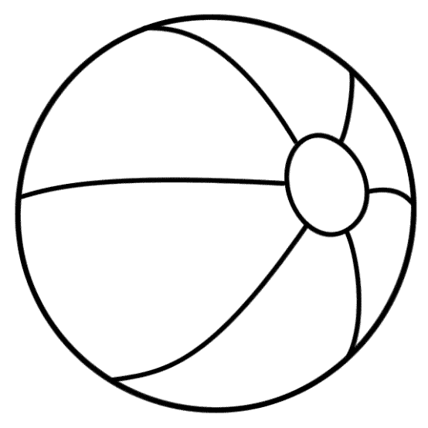

Q3. Find out words

Fox pot six jim

A f o x z u l
C t x l j I m
S i x n o s n
E m s r p o t

Crossword
 |  | net
 |  | 10 |  | nib
 |  |  |  | bus
sun

