|  |
| --- |
| **S V P M ‘ S**  **Shivai Vidyalaya English Medium school**  **Olive Oodles (Pre-Primary )**  **Shivai Nagar Thane** |
| **Name Std :-Nursery Date** |
| **Subject:- G.K. Worksheet No :- Teachers Sign** |

Q .1 Copy Same Letter

|  |  |
| --- | --- |
| D |  |
| P |  |
| R |  |
| U |  |
| J |  |

**Q . 2 See the Letter And Circle The Correct Picture**

|  |  |  |  |
| --- | --- | --- | --- |
| s | Image result for cat drawing images | Image result for elephant drawing images | Image result for sun drawing images |
| Q | C:\Users\Admin\Desktop\rucha\2.gif | Image result for Queen drawing images | Image result for peacock drawing images |
| R | Image result for rain drawing images | Image result for apple drawing images | Image result for horse  drawing images |
| G | C:\Users\Admin\Downloads\Butterfly 2.jpg | C:\Users\Admin\Downloads\d1b616ddd8da5d3503f6c6efdc0ce922.jpg | C:\Users\Admin\Desktop\rucha\2.gif |
| M | C:\Users\Admin\Downloads\cow.jpg | C:\Users\Admin\Downloads\maxresdefault (7).jpg | C:\Users\Admin\Downloads\LcdjdBrc4 (2).png |

|  |
| --- |
| **S V P M ‘ S**  **Shivai Vidyalaya English Medium school**  **Olive Oodles (Pre-Primary )**  **Shivai Nagar Thane** |
| **Name Std :-Nursery Date** |
| **Subject:- G.K. Worksheet No :- Teachers Sign** |

Q .1 Copy the same Numbers 2 times

|  |  |  |
| --- | --- | --- |
| 6 |  |  |
| 7 |  |  |
| 8 |  |  |
| 9 |  |  |
| 10 |  |  |

Q. 2 Circles Only Short Object

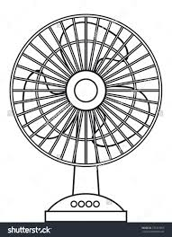 

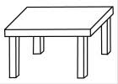 

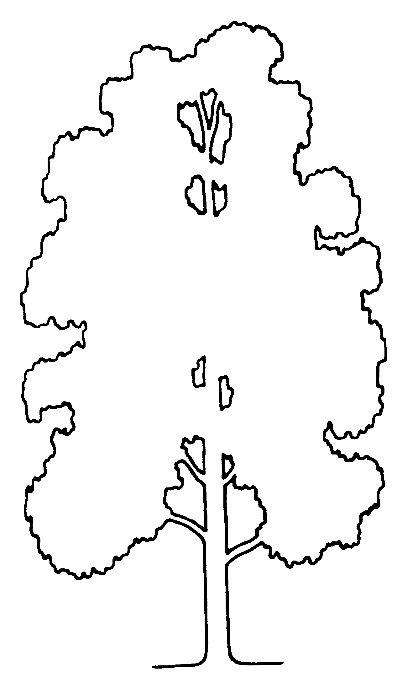 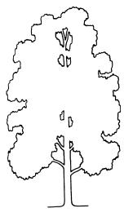

|  |
| --- |
| **S V P M ‘ S**  **Shivai Vidyalaya English Medium school**  **Olive Oodles (Pre-Primary )**  **Shivai Nagar Thane** |
| **Name Std :-Nursery Date** |
| **Subject:- G.K. Worksheet No :- Teachers Sign** |

Q.2 Identify the water Animals and circle it

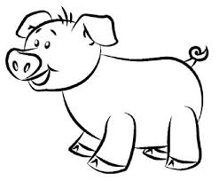 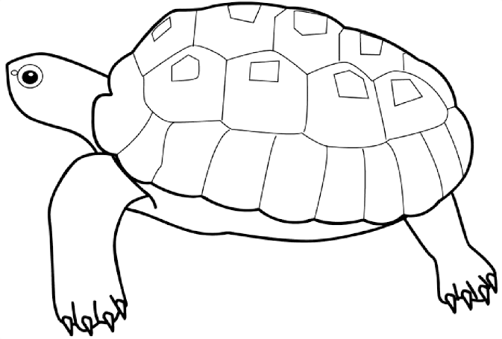 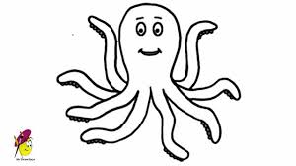 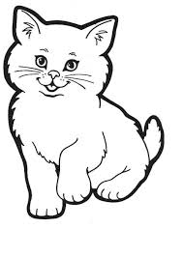 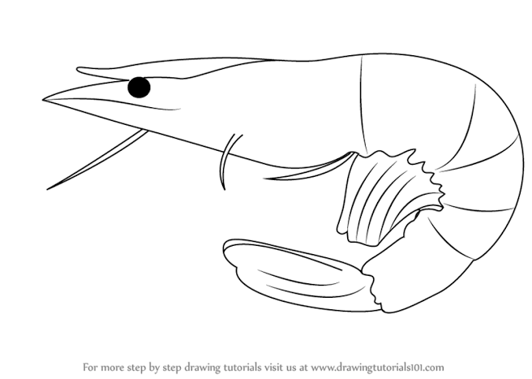 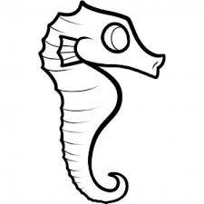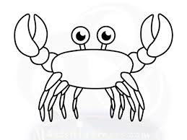 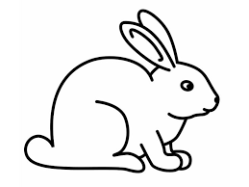 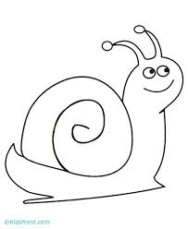

Q . 2 See the shape and match with Appropriate Picture

