|  |
| --- |
| **S V P M ‘ S**  **Shivai Vidyalaya English Medium school & Jr. college**  **Olive Oodles (Pre-Primary )**  **Shivai Nagar Thane** |
| **Name : Std : JR. KG Date:** |
| **Subject : English Worksheet No. 5 Teachers Sign:** |

**Q1. Identify the picture and write the beginning letter of picture.**

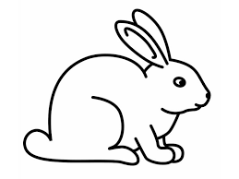  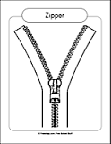

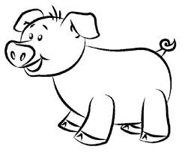  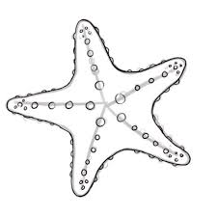

**Q2. Copy the words.**

**at - __________ as - _________**

**an - __________ am - _________**

**he - __________ we - _________**

**me - _________ be - _________**

**Q3. Circle the objects that begin with letter.**

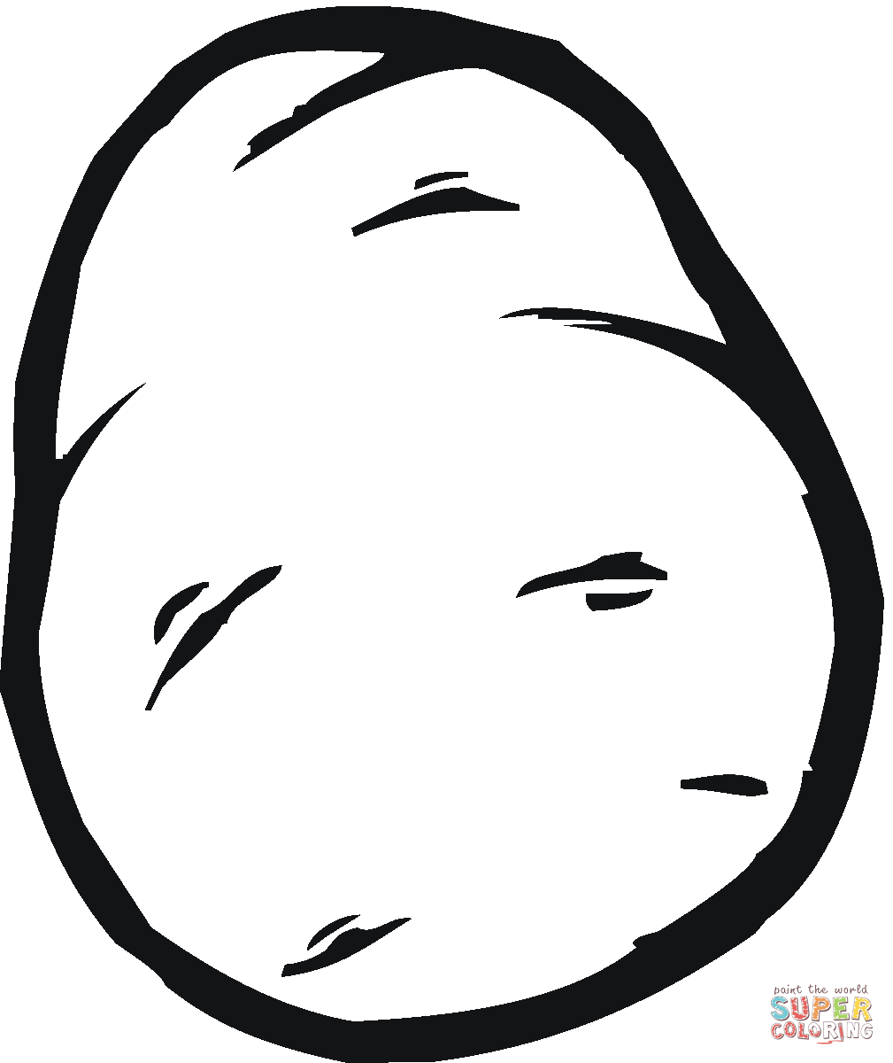  

  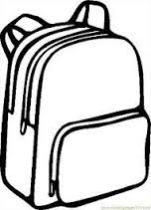

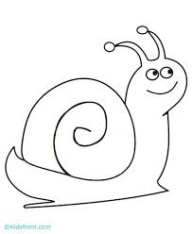 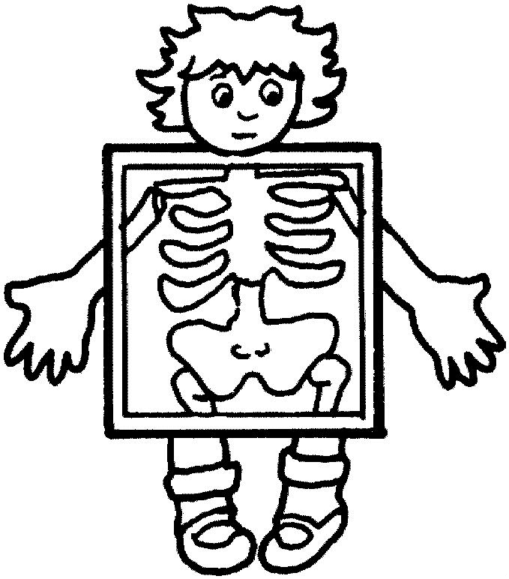 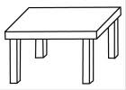

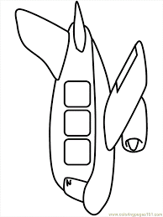 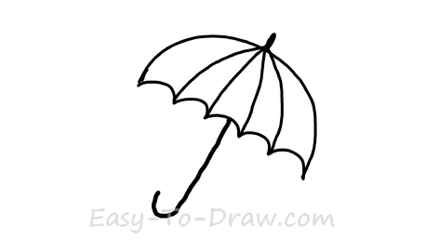 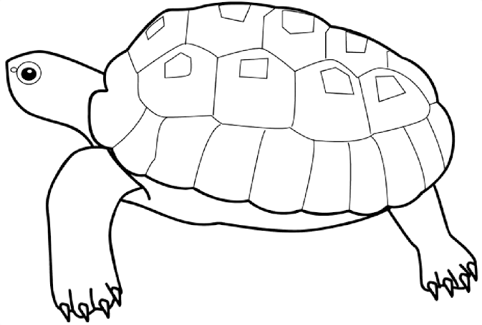

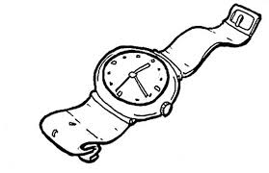 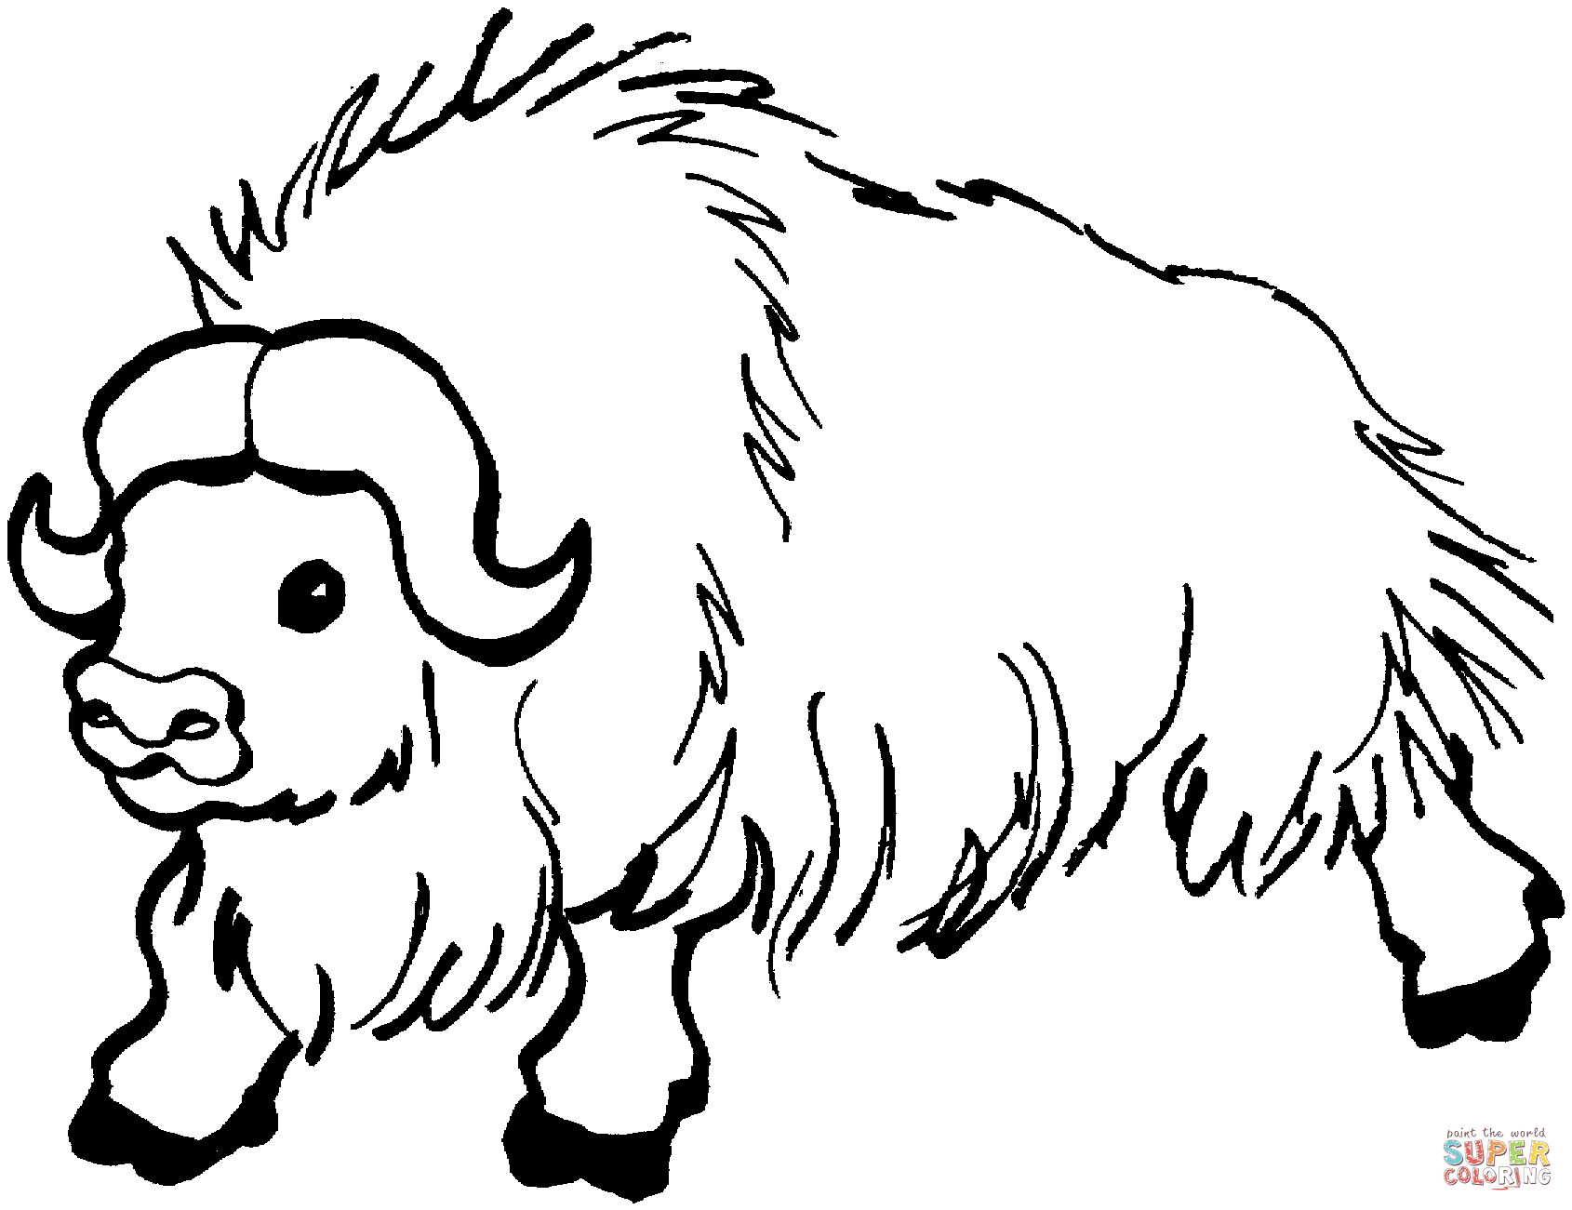 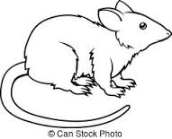

**Q4. Circle the Vowel.**

**h y b a k I n b**

**e p g o c s u w**

|  |
| --- |
| **S V P M ‘ S**  **Shivai Vidyalaya English Medium school & Jr. college**  **Olive Oodles (Pre-Primary )**  **Shivai Nagar Thane** |
| **Name : Std : JR. KG Date:** |
| **Subject : Maths Worksheet No. 5 Teachers Sign:** |

**Q1. Write missing no. 1-40**

|  |  |  |  |  |  |  |  |  |  |
| --- | --- | --- | --- | --- | --- | --- | --- | --- | --- |
| **1** |  | **3** |  | **5** |  |  | **8** |  | **10** |
| **11** | **12** |  |  | **15** | **16** |  | **18** |  | **20** |
| **21** |  |  | **24** |  |  | **27** |  | **29** | **30** |
| **31** |  | **33** |  | **35** |  |  | **38** |  | **40** |

**Q3. Match the front portion to the back portion.**

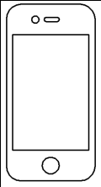 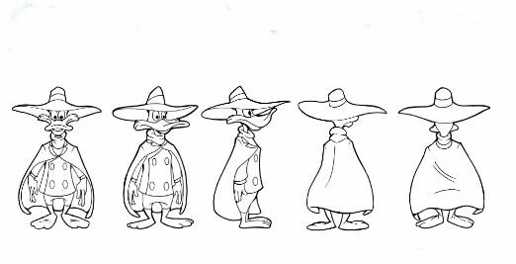

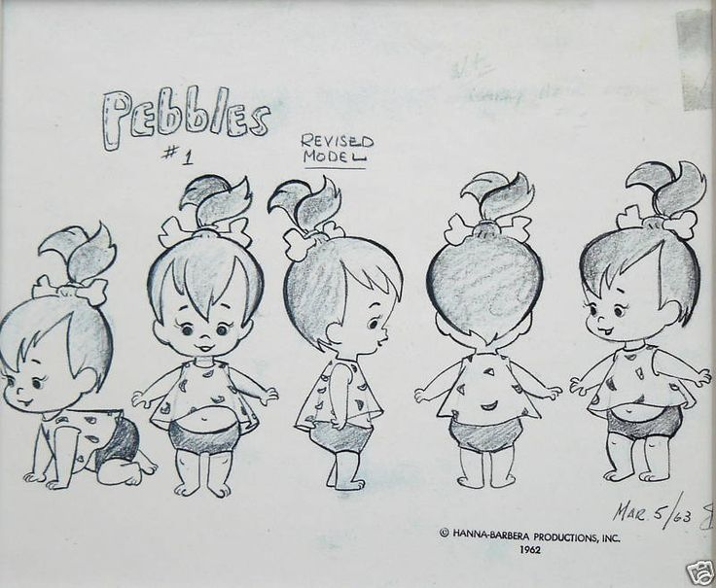 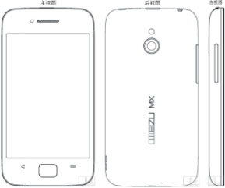

 

**Q4. Cross the one that is different.**

|  |
| --- |
| **C:\Users\Admin\Downloads\Brinjal.png C:\Users\Admin\Downloads\Cabbege.png C:\Users\Admin\Downloads\Brinjal.png C:\Users\Admin\Downloads\Brinjal.png** |
| **C:\Users\Admin\Downloads\Ball 2.png C:\Users\Admin\Downloads\Ball 2.png C:\Users\Admin\Downloads\Cricket ball.jpg C:\Users\Admin\Downloads\Ball 2.png** |
| **C:\Users\Admin\Downloads\0fa96fa995b3f3003b16f0d209ebcd41.jpg C:\Users\Admin\Downloads\0fa96fa995b3f3003b16f0d209ebcd41.jpg C:\Users\Admin\Downloads\Banana.png C:\Users\Admin\Downloads\0fa96fa995b3f3003b16f0d209ebcd41.jpg** |

**2. Write number Names 1-5**

1. **- _____________**

**2- _____________**

**3- _____________**

**4- _____________**

**5- _____________**

|  |
| --- |
| **S V P M ‘ S**  **Shivai Vidyalaya English Medium school & Jr. college**  **Olive Oodles (Pre-Primary )**  **Shivai Nagar Thane** |
| **Name : Std : JR. KG Date:** |
| **Subject : G.K Worksheet No. 5 Teachers Sign:** |

Q1. Tick the Electrical Things only

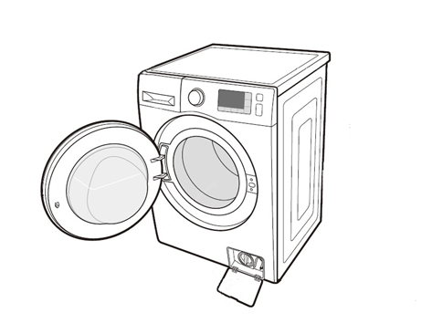  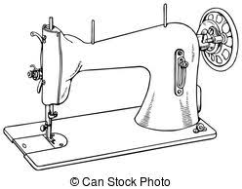 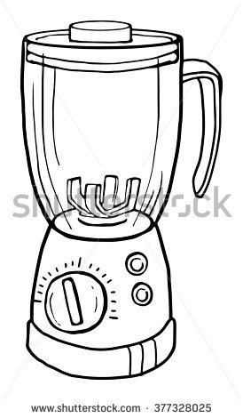

 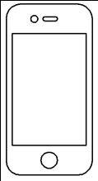 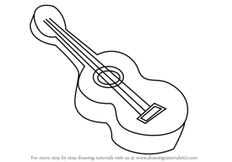 

**Q2. Circle only the insects.**

  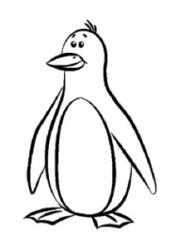 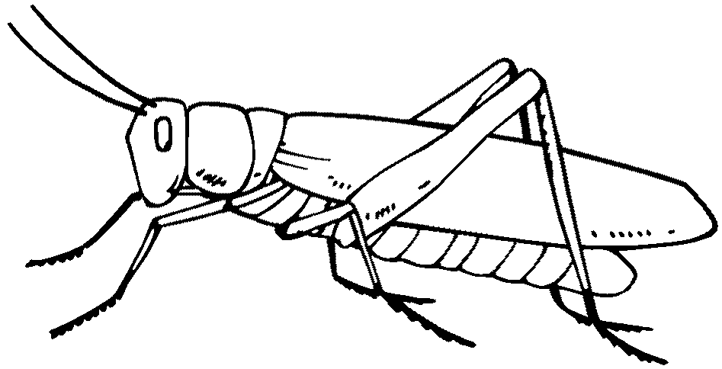

 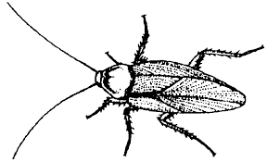 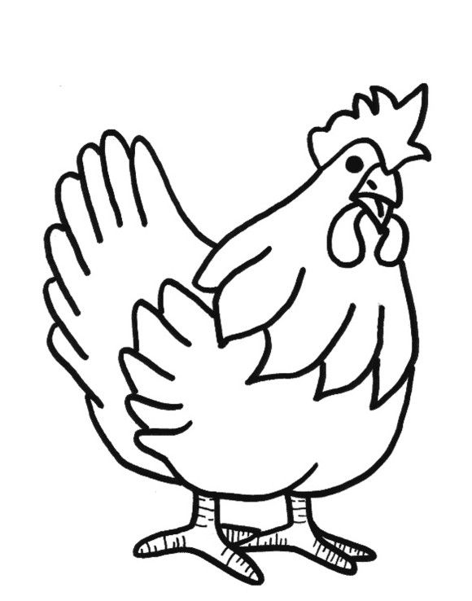 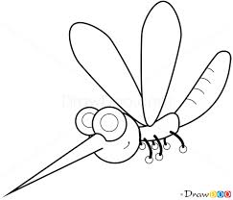

**Q. 3 Match the following.**

 