S V P M ‘ S
Shivai Vidyalaya English Medium school
Olive Oodles (Pre-Primary )
Shivai Nagar Thane
Name Std :-SR. KG Date
Subject:- G.K. Worksheet No :- 6 Teachers Sign
Q.1.Write the correct word.
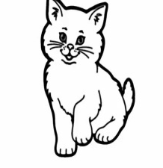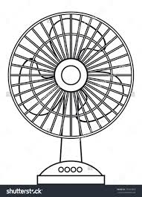

Q.2.Cross the odd one out.
Bug dug hug bun

Set nut hut but

Nun run rug sun

Q.3.Use these words: moon, room, roof, boot.
1) The m __ __ __ is old.

2) My b ___ ___ ___ is too big.

3) I play in my ___ ___ ____ m.

4) The ___ ___ ___ f is red.
Q.4.Crossword puzzle.

Q. 5. Fill in the blanks.
1) The is up.

2) He has fun in the

3) A is on the

S V P M ‘ S
Shivai Vidyalaya English Medium school
Olive Oodles (Pre-Primary )
Shivai Nagar Thane
Name Std :-Sr.KG Date
Subject:- Maths Worksheet No :- 6 Teachers Sign
Q.1.Sovle the following.
3 5 6
_ 3 _ 3 _ 0
________ _______ ________

______________________________________________________

5 7 4
+ 0 + 2 + 4
________ __________ ________

_____________________________________________________________
Q. 2. Make a bundle of ten and extra.
1) 15

____________________________________________________________
2) 17

__________________________________________________________
3) 13

Q.3.Draw the pattern.

Q.4.Match the ordinal numbers.
First 2nd

Tenth 8th

Eighth 1st

Second 10th
Q.5. Write down the missing numbers.
61 |  |  | 6 4 |  |  |  |  |  | 70

91 |  | 93 |  |  |  |  |  |  | 100

71 |  |  |  | 75  5 |  |  |  |  | 80

S V P M ‘ S
Shivai Vidyalaya English Medium school
Olive Oodles (Pre-Primary )
Shivai Nagar Thane
Name Std :-Sr.KG Date
Subject:- G.K. Worksheet No :- Teachers Sign
Q. 1. Match the old & new things.
Telephone
Quill 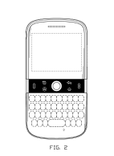 mobile
letter computer

type writer e mail

Q.2. fill in the blanks
- Children’s day celebrated on -------------------------------

- Gandhi jayanti is celebrated on -------------------------------

- 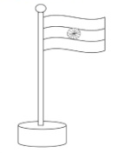Independence day is on ----------------------------------------

Q.3. Match the community helpers with their tools
