S V P M ‘ S
Shivai Vidyalaya English Medium school & Jr.Collage
Olive Oodles (Pre-Primary )
Shivai Nagar ,Thane
Name :- Std :- Nursery . Date:-
Subject :- English Worksheet No :- 4 Teacher’s Sign:-
Q.1 See the letter and join correct picture
O
Q

K 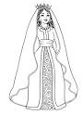

Y 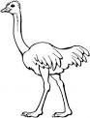
Z

Q.2 Identify the same letter and trace it.

I | T I I
N | O N N
A | A A N
S | S G S
G | G F G
U | R U U

S V P M ‘ S
Shivai Vidyalaya English Medium school & Jr.Collage
Olive Oodles (Pre-Primary )
Shivai Nagar ,Thane
Name :- Std :- Nursery . Date:-
Subject :- English Worksheet No :- 4 Teacher’s Sign:-
Q.1 find out the same number and circle it
5 | 5 8 9 6 5 5 4 5
3 | 9 3 6 3  4 3 2 3

7 | 7 9 7 5  7 5 7 5

9 | 9 8 9 6 5 9 3 9

1 | 1 8 9 1  5 1 5 1

Q.2 circle the things which are the light
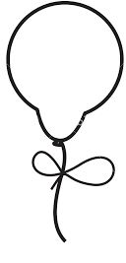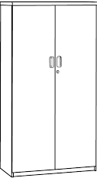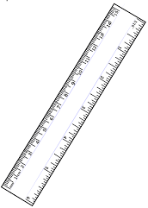
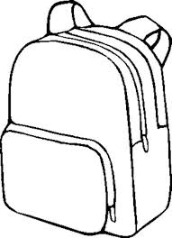
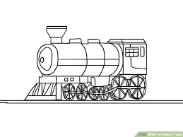

S V P M ‘ S
Shivai Vidyalaya English Medium school & Jr.Collage
Olive Oodles (Pre-Primary )
Shivai Nagar ,Thane
Name :- Std :- Nursery . Date:-
Subject :- English Worksheet No :- 4 Teacher’s Sign:-
Evs
Q.1 . colour the picture with appropriate colour
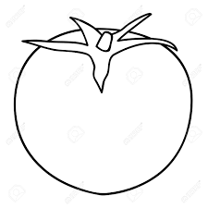
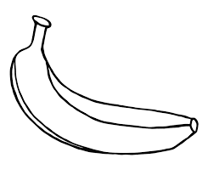
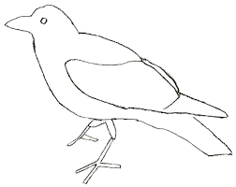
Q..2 Match correct actions with their pictures.
