S V P M ‘ S
Shivai Vidyalaya English Medium school & Jr. college
Olive Oodles (Pre-Primary )
Shivai Nagar Thane
Name : Std : JR. KG Date:

Subject : Maths Worksheet No. 6 Teachers Sign:

Q1. Write Number Name.
6- _________________ 7 - _____________________

8 - _________________ 9 - _____________________

10- ________________ 3 - _____________________

Q2. Write in order.
4 3 5 2 1 _____________________________

Q3. Write Between Number.
1. 8 10 2. 5 7 3. 1 3

Q4. Write After no.
- 2 2. 4 3. 6 4. 9

Q5. Write Before no.

- 6 2. 9 3. 2

Q6. Count and Add.
+ =

+ =

Q7. Subtraction

5 - 2 = 3 - 1 =

S V P M ‘ S
Shivai Vidyalaya English Medium school & Jr. college
Olive Oodles (Pre-Primary )
Shivai Nagar Thane
Name : Std : JR. KG Date:

Subject : English Worksheet No. 6 Teachers Sign:

Q1. See the picture and write.
____at R____t
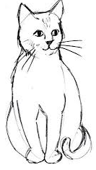 Ca____ ____ap
Q 2. Write ending sound of picture.

Q3. Match the picture with words.

dot

ten

pin

rat

mat

S V P M ‘ S
Shivai Vidyalaya English Medium school & Jr. college
Olive Oodles (Pre-Primary )
Shivai Nagar Thane
Name : Std : JR. KG Date:

Subject : G. K Worksheet No. 6 Teachers Sign:

Q1 Match te community helpers with their tools.
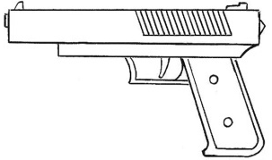
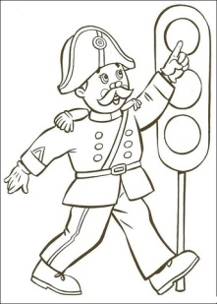
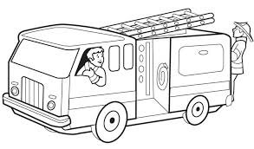
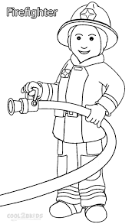
Q. 2 Draw Stationary things.

Q 3. Circle the National symbols.

